Choices Topic for September: **Bullying Awareness**

**What is Bullying?**

Bullying is when someone targets another person and uses intentional aggressive behavior to gain power or strength. Bullying involves making threats, or hurting someone with words or actions.

**Did you know…**

There are many different types of bullying. These include but aren’t limited to:

**Verbal Bullying:** teasing, taunting, threatening

**Social Bullying:** rumors, excluding, embarrassing

**Physical Bullying:** pushing, spitting, hitting, stealing

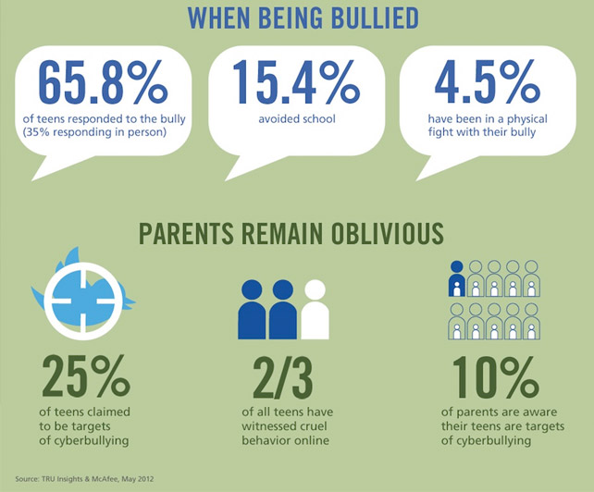

**Cyber Bullying- Delete It!**

Cyber bullying can be:

* Anonymous: you may not even know the culprit
* Permanent: what’s posted on the internet can be nearly impossible to delete
* Public: one re-post or re-tweet, and it can become viral
* Omnipresent: you can be instantly connected to cyber bullying on your cell phone or internet

**What Does Cyber Bullying Look Like?**

* Online Harassment
* Outing
* Victim Blaming/Shaming
* Trolling/Masquerading

**Parents, Faculty and Staff:**

* What are your family/classroom rules regarding your teen’s communication via the internet or cell phone?
* How do you know if your child is being bullied on the computer?
* Are you available to talk to if teenagers are having a problem with bullying?
* What can you do if you suspect your child/student is being bullied?

For more resources checkout on the links below:

[www.stopbullying.gov](http://www.stopbullying.gov), <http://kidshealth.org/teen/your_mind/problems/bullies.html>, <http://www.pacerteensagainstbullying.org/#/home> http://nobullying.com/

How can you delete cyber bullying?

Don’t write it!

Don’t forward it!

Report it!

**Sam Scharff, LCDC, LPC-intern**  **A148 sscharff@EHSHouston.org**

**Students:**

* How does it feel when another student is saying negative things about you?
* How do you know when to tell someone you are being bullied?
* How do you keep yourself safe from cyber bullying?
* What can you do if you suspect a friend is being bullied?
* What would you do if someone threatened you over a text message?

Discussion Questions & Cyber Bullying Information: