Choices Topic for April: Drug Use

**Marijuana**

**How does Marijuana affect the brain?**

THC (delta-9-tetrahydrocannabinol) is the main chemical that affects the brain when marijuana is smoked. THC passes from the lungs to the blood stream and then to the brain and entire body. A release of dopamine is triggered which creates the pleasurable “high” feeling. However other core effects include change in perceptions, mood, lack of coordination, difficulty thinking and disrupted learning and memory.

**Is it addictive?**

Yes, Marijuana is highly addictive and abused and can produce significant withdrawal and dependence.

**But it’s “natural”…**

Some believe because Marijuana is “natural,” it cannot be harmful. This is a MYTH! Not all “natural” substances are safe (tobacco, etc.)

**Signs of Withdrawal:**

Irritability, sleeplessness, lack of appetite, anxiety, drug craving

**Drugs & the Brain:**

Teenage brains are currently under construction, meaning that their prefrontal cortex is now in a development stage and will be until they are about 25 years old. So what happens to teenage brain development if teenagers introduce drugs or alcohol into their bodies? It is simple. While the chemicals are in their bodies their brains stop developing. We call this arrested development. Drugs and alcohol literally shut off the use of most of our brains, which also explains why it is hard for people to make good rational decisions when they are under the influence. It is important for teenagers (and everyone else for that matter) to understand that drugs and alcohol will literally stunt their brain growth.

Discussion Questions: Drug Use and Addiction

**Parents, Faculty and Staff:**

* Have you ever engaged in marijuana use? If not, have you shared your reasons for abstaining with your kids?
* How can we further prevent teens from engaging in drug use?
* What can you do if your student/child is addicted to a drug of choice?
* If you find out that your student/child is smoking marijuana, should you be concerned about his or her use of other drugs?
* How and when should you talk to your students/children about drug use?

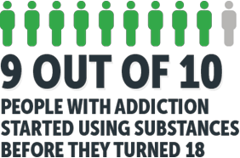

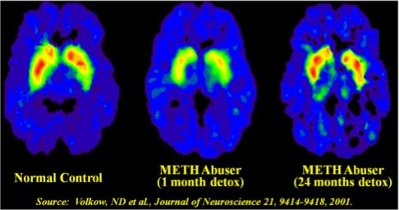

**Signs and Symptoms of Marijuana Use:**

-bloodshot eyes - increased risk for mental health problems

-incrased heart rate -reduced school performance

-increased appetite -impaired driving

-memory impairment

-difficulty paying attention or solving problems

-anxiety - gateway to other drugs

-fear or panic

-hallucinations

-paranoia and delusional behavior

**Students:**

* Have you ever tried marijuana or synthetics and why?
* How would you say no to smoking marijuana if all of your friends were doing it?
* Why do you think teenagers are engaging in drug use?
* How might you as a non-drug using teenager encourage your peers not to use?
* What are healthy coping mechanisms for stress and anxiety that could replace using?

**Sam Scharff, LCDC, LPC-intern Office A148 sscharff@EHSHouston.org**

Resources:

http://teens.drugabuse.gov/ http://www.narconon.org/ http://www.getsmartaboutdrugs.com/