Choices Topic for January: **Gambling**

**Facts and Stats:**

* 1 in 8 of 8,000,000 gamblers are teenagers
* 80% of teenagers gamble in some way and 15% are problem gamblers
* Students who gamble excessively are more likely to use substances, and vice versa

**Signs & Symptoms of Problem Gambling:**

* Increase in frequency & amount gambled
* Student withdraws from friends and family
* School absences
* Excessive time on the internet
* Stealing or borrowing money for gambling
* Anxiety, nervousness or irritability
* Lying or secretive behavior
* Frequent mood swings related to winning or losing
* Over-involvement in sporting event results
* Grades declining



Compulsive Gambling is considered an issue related to poor impulse control. Individuals who compulsively gamble have a need for instant gratification and can become irritable or impatient when delayed. Teens are at risk because the area of the brain that is responsible for impulse control, the prefrontal cortex, is still developing. One sign of problem gambling is going back the next day to win back what was lost.

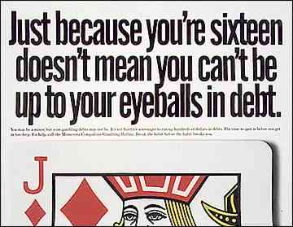

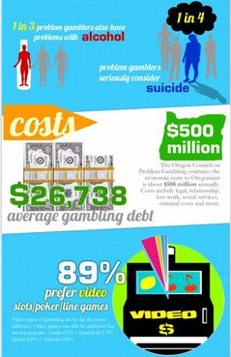

**Sam Scharff, LCDC, LPC-intern A148 sscharff@EHSHouston.org**

**Resources:** CRC Health Group: <http://www.crchealth.com/troubled-teenagers/teen-gambling/> , Department of Behavioral Health and Intellectual Disability services: <http://dbhids.org/gambling> , Teen Health: [http://kidshealth.org/teen/your_mind/problems/gambling.html#](http://kidshealth.org/teen/your_mind/problems/gambling.html)

**Parents, Faculty, Staff:**

* What behaviors do you model for your child/student about gambling?
* How is spending modeled in the family?
* How do you think your spending habits affect your child/student?
* How much time does your child spend on the internet per day?
* Your child/student is compulsively gambling, what do you do?

**Students:**

* How does gambling affect your life?
* Do any of your peers gamble?
* Have you ever gambled at school?
* When should you draw the line on how much you gamble?
* How much time do you spend on the internet per day?
* Do you ever spend money you don’t have?

Discussion Questions & Information

Resources: <http://nedawareness.org/>, Binstock, Melissa. Nourishment; Eubanks, Michelle. Times Daily.com. *Girls’ Self-Esteem Coming Under Fire;*  Ahern, Patti. Combating ‘Onlsaught’ on Girls. Chicagotribune.com; Sathe, Michelle. “Filmmaker leaves ‘Mark’ with Documentary.” [www.the-signal.com/news/article/20413](http://www.the-signal.com/news/article/20413); Hornbacher, Marya. *Wasted*. , <http://nedawareness.org/>

**Shelly Simpson, LMSW SSimpson@EHSHouston.org**