**Choices Topic: How to Prevent High Risk Behavior over the Summer!**

**Did You Know?!**

* During the months of May through August, teen deaths increase. This is largely credited to **alcohol consumption** and **drinking while driving**
* Self-care and boredom can increase the likelihood that a young person will experiment with drugs and alcohol by as much as **50 %.**
  + - * Summer can also be prime time for technology use to increase.
      * Internet abuse or overuse can interfere with real life relationships.

**RECOGNIZE THE TWO TYPES OF PEER PRESSURE**

**Direct social pressure** is when someone offers you a drink or an opportunity to drink.

**Indirect social pressure** is when you feel tempted to drink just by being around others who are drinking—even if no one offers you a drink.

[](http://www.google.com/url?sa=i&rct=j&q=&esrc=s&frm=1&source=images&cd=&cad=rja&uact=8&ved=0ahUKEwixwISh_aDMAhUEr4MKHdvTDYYQjRwIBw&url=http://www.blogbank.org/2014/03/payment-processing-for-everyone.html&bvm=bv.119745492,d.amc&psig=AFQjCNEE5OvoURjUlJSccuKj0MQcuPNKzQ&ust=1461370953286245)[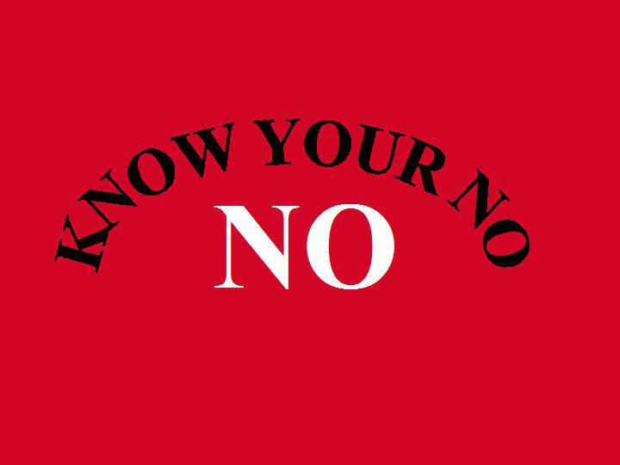](http://www.google.com/url?sa=i&rct=j&q=&esrc=s&frm=1&source=images&cd=&cad=rja&uact=8&ved=0ahUKEwj96tm36KDMAhVE4SYKHTv4AboQjRwIBw&url=http://www.davidzinger.com/wednesdaywork-poemno-3060/&psig=AFQjCNEggdhRpD4Wu6Npl4f6rb5FpPh44g&ust=1461365312289871)

Resources: <http://www.lockthecabinet.com/news/risky-behavior-teens-summer/> https://www.verywell.com/fun-things-for-teens-to-do-this-summer-2611143

<https://www.health.ny.gov/prevention/injury_prevention/children/toolkits/teen_driving/teen_toolkit.htm> <http://www.afterschoolalliance.org/issue_briefs/issue_CrimeIB_27.pdf>; <http://www.gishpicks.com/> https://www.teenlife.com/blogs/10-summer-activities-will-turn-admissions-heads

**Students:**

1. Do you ever get triggered to engage in high-risk behavior when you are bored?

2. How can you find healthy activities to engage in over the summer?

3. What is your favorite refusal skill? What do you say no to and what do you struggle with?

4. How can you use peer pressure positively?

5. What are your values regarding how to spend your summer? Do you prefer to relax or get involved with a project?

6. How can you resist getting completely lost in technology?

**10 SUMMER ACTIVITIES THAT WILL TURN ADMISSIONS OFFICERS HEADS**

1. **Volunteering**
2. **Start a business**
3. **Take classes**
4. **Intern**
5. **Spend the summer abroad**
6. **Work on a charity project**
7. **Work at a summer camp**
8. **Attend college classes for high school students**
9. **Visit colleges and make connections**
10. **Create an online presence by starting a blog or webpage**

**Too Much Family Time? Bored Out of Your Mind?—Here’s Your 5 Minute Fix!**

* **Grin and Bear it- smiling can instantly lift your mood**
* **Call a Friend- sometime you just need to vent!**
* **Smell a Sweet Scent- lavender and peppermint can calm and energize**
* Visualize- imagine your favorite place to be…
* Meditate- Even taking a few deep, breaths can help destress
* DIY Massage-Releasing tension can ease your mind and body
* Tune in- Music can energize and relax you
* Close your eyes-A few minutes can calm and reboot
* Take a Walk- exercise can boost endorphines and calm you down!

**Faculty and Parents:**

1. Do you require your adolescent to engage in productive activities over the summer like work or service projects?

2. Where can you find summer camps and local cultural events over the summer?

HINT: <http://www.gishpicks.com/>

3. Do you know how much video game and technology activity is too much?

4. How do you monitor your adolescent’s summer activities?

5. What can you do as a parent or teacher to help students adjust to summer schedules?

**Discussion Questions**

**Not now**

Sorry, I can’t

**NOT COOL MAN!**

**My school tests**

**My parents would kill me!**

**No Thanks!**

**HOW DO YOU SAY NO?**

YOU HAVE THE RIGHT TO REFUSE

**Sam Scharff, LCDC, LPC-intern Choices Counselor**

**Under the supervision of Crystal Collier, PhD, LPC-S Office A148 sscharff @EHSHouston.org**

[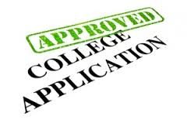](https://www.google.com/url?sa=i&rct=j&q=&esrc=s&frm=1&source=images&cd=&cad=rja&uact=8&ved=0ahUKEwizlrbBhqHMAhXMtoMKHetlCMYQjRwIBw&url=https://www.collegerecruiter.com/blog/2014/12/05/college-acceptance-friendship-social-trap/&bvm=bv.119745492,d.amc&psig=AFQjCNGyBBDuO2lPVlqz7U86AyZm3u6ISw&ust=1461373424354200)