**Choices Topic for December: Stress Management**

**Let’s talk about stress!**

Stress is a natural part of our lives. Stress is caused by internal or external changes that can be positive or negative. Our brain signals to our body when we are feeling stress and this tells us we must do something to adapt. There are various types of stress including social, physical, family, school, and work stress.

This can be an especially stressful time for teens with the end of the semester and finals approaching. It is a very important time for parents to pay attention, monitor their teen’s health and behavior, listen carefully, and model healthy stress management skills.

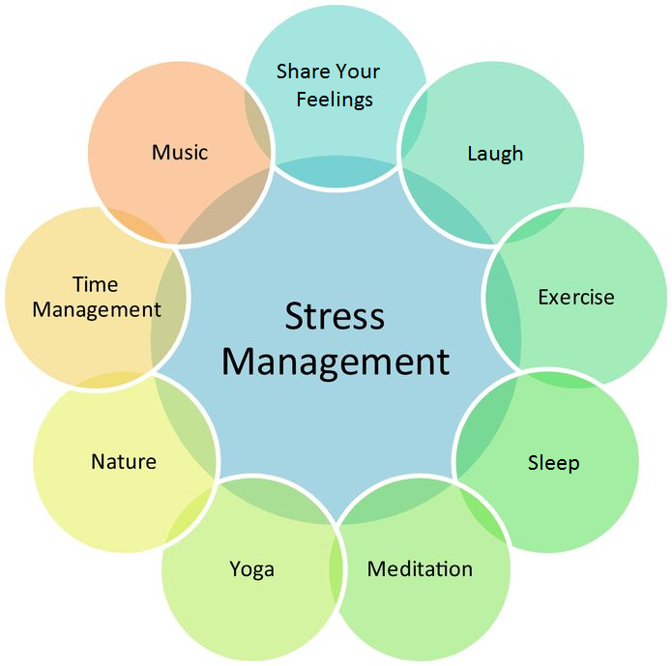

**Ways to Become Stress-Resistant**

Stop feeling guilty.

Be decisive.

Avoid being a perfectionist.

Set priorities for yourself.

Stop procrastinating.

Praise yourself.

Live an optimal lifestyle.

**Feeling Stressed? 5 Minute Fixes to the Rescue!**

* **Grin and Bear It- smiling can instantly lift your mood**
* **Call a Friend- sometimes you just need to vent!**
* **Smell a Sweet Scent- lavender and peppermint can calm and energize**
* Visualize- imagine your favorite place to be…
* Meditate- even taking a few deep breaths can help destress
* DIY Massage-releasing tension can ease your mind and body
* Tune in- music can energize and relax you
* Close Your Eyes-a few minutes can calm and reboot
* Take a Walk- exercise can boost endorphines and calm you down!

**Discussion Questions & Facts:**

**Sam Scharff, LCDC, LPC-intern Choices Counselor**

**Under the supervision of Crystal Collier, PhD, LPC-S Office A148 sscharff @EHSHouston.org**

Resources: <http://www.healthiersf.org/resources/pubs/stressRed/StressReductionActivities.pdf> <http://positivemed.com/2012/11/26/what-stress-does-to-your-body/>

<http://skinnyms.com/stress-and-your-health-does-stress-make-you-fat/> <http://www.brocku.ca/health-services/health-education/stress/eustress-distress> <http://www.sparkpeople.com/resource>

**Faculty, Staff, and Parents:**

* Are you stressed out? If so, how are you modeling healthy stress management behavior?
* How do you cope with stress?
* What types of stress do you experience?
* If your teen/student is overwhelmed and stressed out, what do you do?
* Do you talk with your teen/students about the effects stress has on our bodies?

**Students:**

* What is stress?
* Are you stressed? If so, what types of stress are you experiencing?
* How do you know when you are stressed?
* How do you cope with stress?
* When do you talk to your parents about stress?
* How do your parents model healthy stress management behavior?
* A friend is stressed out; what do you do?