Choices Topic for February: **Body Image**  **& Eating Disorders**

The beauty and diet industries, combined with what is seen on TV, in magazines, and online greatly shapes many expectations of beauty. These expectations can be idealized and are often unattainable, leading to low self-esteem, poor body image, and eating disorders.

**What is Body Image?**

-The way someone perceives their body and assumes others perceive them.

-This image is often affected by family, friends, social pressure and the media.

**Facts and Stats:**

* 95% of people suffering from eating disorders are between the *ages of 12-25*.
* *1 in 6 cases* of eating disorders diagnosed are in *men*.
* In the US, 2 out of every 100 *students* will struggle with an eating disorder.
* Only *4% of women* around the world consider themselves beautiful.
* Eating disorders have the *highest mortality rate* of any mental illness.

**BINGE EATING DISORDER** Recurring episodes of eating significantly more food in a short period of time, marked with feelings of lack of control. May have guilt, embarrassment or disgust and may binge alone



* Eating an unusually large amount of food at one time followed by compensatory behaviors (such as vomiting, taking laxatives, excessive exercise) to prevent weight gain
* Typically triggered by anxiety, depression, stress or intense hunger following dietary restrictions or negative feelings related to body weight, shape, and food
* Refusal to maintain a minimally normal body weight
* Intense fear of gaining weight
* Significant disturbance in the perception of the shape or size of one's body
* Often accompanied by depressed mood, social withdrawal, irritability, insomnia, or anxiety



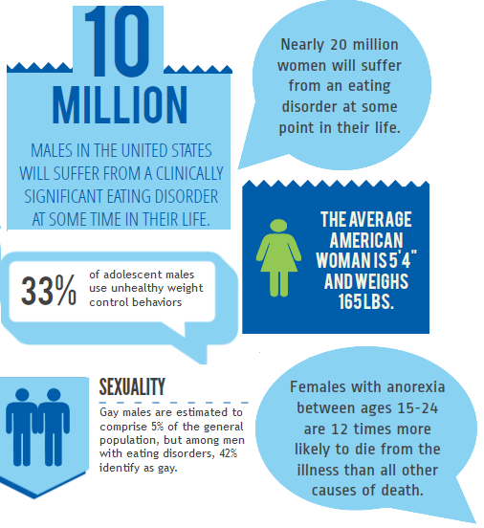

**{Despite Media Portrayal}**

[Resources: http://www.anad.org/ http://nedawareness.org/](Resources:%20http://www.anad.org/%20%20http://nedawareness.org/), Binstock, Melissa. Nourishment; Eubanks, Michelle. Times Daily.com. *Girls’ Self-Esteem Coming Under Fire;*  Ahern, Patti. Combating ‘Onlsaught’ on Girls. Chicagotribune.com; Sathe, Michelle. “Filmmaker leaves ‘Mark’ with Documentary.” [www.the-signal.com/news/article/20413](http://www.the-signal.com/news/article/20413); Hornbacher, Marya. *Wasted*. , <http://nedawareness.org/>

**Sam Scharff, LCDC, LPC-i A148 sscharff@EHSHouston.org**

**Parents, Faculty, Staff:**

* What behaviors do you model for your child/student about eating and body image?
* What is the best way you have found to boost your child’s/student’s self-esteem?
* What pressures do you experience related to body image?
* How do you think your own body image issues affect your child/student?
* How can you help someone improve their body image?
* How would you go about getting your child help for body image issues?

Discussion Questions & Information

**Students:**

* What do you tell yourself about the way you look?
* In what way is your body image affected by society and the media?
* What are your own rules about eating and exercise?
* What would be the best way to approach a friend who may need help with an eating disorder?
* What can you do to improve your own body image?
* What can you do to help others improve their body image?