**Sam Scharff LCDC, LPC-i @EHShouston.org**

**8 Ways to Make Social Media a Better Place:**

1. **BE POSITIVE:**Share the exciting things in your life and the things that bring you joy!
2. **DON’T JUDGE OTHERS:**
3. **3. USE THAT “LIKE” BUTTON:**
4. **4. THINK BEFORE YOU POST:**A few questions to ask yourself before posting a thought or picture: “Will this hurt anyone?” “Is this positive?” “Is this necessary?” Think about your intentions on why you are posting it.
5. **5. YOUR WORTH IS NOT BASED ON HOW MANY “LIKES” YOU GET**
6. **6. IF YOU DON’T HAVE ANYTHING NICE TO SAY, DON’T SAY ANYTHING AT ALL:**
7. **7. SHARE WHAT YOU BELIEVE:**
8. **8. CREATE A BALANCE:** There is definitely a time and a place to pull out your phone and cruise – but there is also a time and a place to put it away and focus on what is right in front of you.

**Facts and Stats:**

Did you know that 8 to 18 year-olds devote an average of 7.5 hours to using entertainment media during a typical day? Furthermore, 9 out of 10 teenagers use or have used social media.

Teens and adolescents are constantly trying to define themselves. They crave positive feedback to help them see how their chosen identity fits into their surrounding world. Therefore, they use social media to immediately gain this information. The problem is, they are looking in a dangerous place.

The danger exists in the possibility of a very public rejection because negative feedback is there for anyone and everyone to see. Another danger is that teens ask for feedback without learning first that not everyone will supportively respond.

-http://www.today.com/moms/selfie-syndrome-why-teens-use-social-media-validation-how-parents-8C11391281

-http://www.mediabistro.com/alltwitter/teens-social-media_b50664 http://socialmediaweek.org/losangeles/2013/06/11/cool-infographic-reveals-social-media-habits-of-teenagers/

**Students:**

* What do you think is appropriate to post online?
* Are you posting something you would be embarrassed for your family to see?
* Are you posting because you are hoping someone will make you feel better about your choices?
* Are you posting things that hurt other people?
* A friend is being bullied online, what do you do?

**Discussion Questions and Quick Facts:**

**Choices Topic for March: Social Media and Technology**

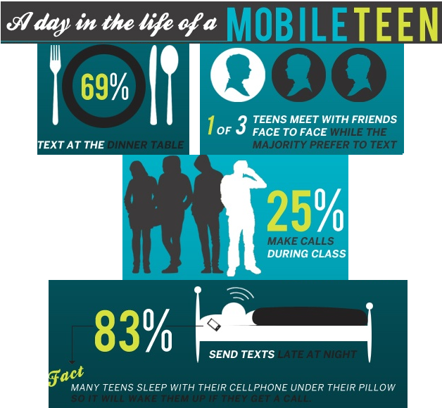

**Parents, Teachers and Staff:**

* What are your rules regarding your teen/student’s use of social media?
* Do you use social media sites? If so, are you modeling healthy online behavior?
* Do you supervise your teen’s social media accounts?
* Your child/student is being bullied online, what do you do?
* Do you talk openly about the dangers and appropriate use of social media with your children/students?