EPISCOPAl ATHLETICS

EPISCOPAL FOOTBALL
Freshman Football- If you have any questions, please contact Coach Leisz at sleisz@ehshouston.org

MAY (SPRING BALL) @ Brown Field
12 SPRING PRACTICE 9:00am-11:00am
(Brown Field- Tennis Shoes, Cleats, Shorts, T-Shirt)

AUGUST (First Week Schedule)
6 Pad Issue and Parent Meeting (Alkek) 5:00pm
7 First Day of Practice 9:00am-12:00pm
8 Practice 9:00am-12:00pm
9 Practice 9:00am-12:00pm
10 Practice 9:00am-12:00pm
11 Intra-Squad Scrimmage 9:00am

Knight Power (Coed)
June 4 - 28 (Monday-Thursday)
8am-9:15am
Cost: $250
Grades: Incoming Freshmen – Boys and Girls
Instructors: Head Athletic Trainer - Marc Klinkerman , Head Football & Head Wrestling Coach -Steve Leisz, and Dick Phillips – Former Head Track and Head Football Coach (retired)
This program offers weight training, flexibility development, agility training, plyometrics, and speed training with emphasis placed on learning and executing proper technique. The course is designed to improve the athletic performance of student athletes by becoming faster, stronger, and more agile, and less susceptible to injury.
As well, this is a great camp to get to know future classmates before the school year starts. Click the link below to register.
EHS KNIGHT POWER CAMP REGISTRATION
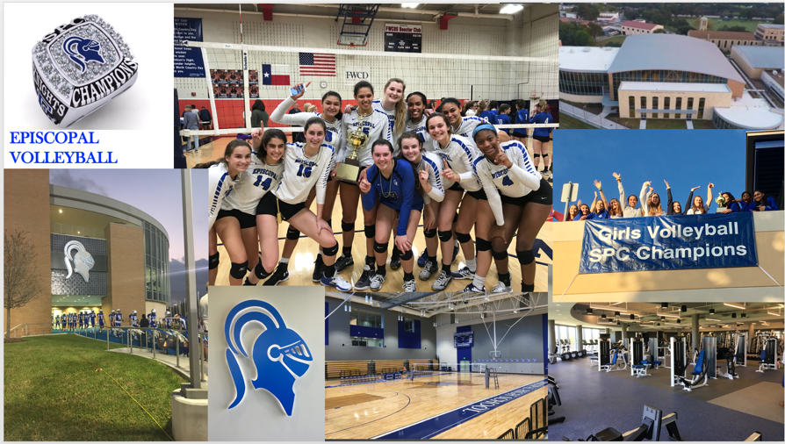
EPISCOPAL VOLLEYBALL

Dear Knights,

I am so excited for the 2018 Volleyball Season! Below is a list of some upcoming dates for spring volleyball, camps and preseason. Next week, every new student-athlete is welcome to join us for spring volleyball. It will take place in Crum Gym Monday through Wednesday (5/7-9) from 4:00-5:30pm. It is not mandatory, but we would love for you to come out if you can make it!

- Spring Volleyball: Open to new and current EHS students. No cost. Monday-Wednesday 4:00-5:30 @ Crum Gym
- Sports Physicals: May 9th @ 5:00pm Alkek Gym. Cost $20.
- EHS Volleyball Camps: June 11-14th and July 16th-19th.
Please go online to register @ EHS Volleyball Camp Registration
- Parent/Player Meeting: August 6th, 2018 5:00pm @ Anderson Lecture Hall
- Volleyball Tryouts: August 6th-8th, 2018 9-11am and 1-3pm @ Alkek Gym. All athletes must have a current physical. I will hand out an August calendar with practice times at the meeting.
- Team Camp: We are looking at the last weekend of July. This is not mandatory for incoming students. I will send out more information at a later date.
- Questions: Contact Coach Amanda Watts @ awatts@ehshouston.org or 214-505-7226

GO KNIGHTS!!

Coach Watts

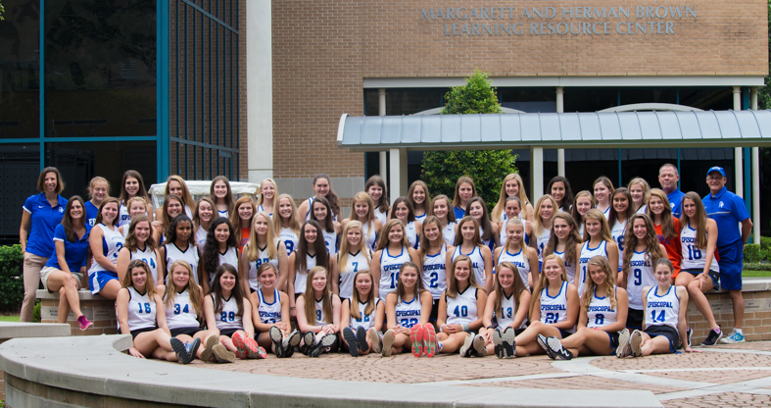
EPISCOPAL FIELD HOCKEY
Hey Knights!

Below is some information regarding the upcoming field hockey dates. Please let me know if you have any questions.

- May Practice: Monday, May14th- Wednesday, May 16th 4:00 pm - 5:30 pm @ Bissonnet Field
- Summer Practice- Every Tuesday and Thursday 9:00 am - 10:30 am (No practice the week of June 25th and July 2)
- Summer Camp: Field Hockey camp will be held June 25-28th Click the link for more information and to register. EHS Field Hockey Camp Registration
- First day of Season: Wednesday, August 8th- 7:30am

GO KNIGHTS!

Coach Edmonds
sedmonds@ehshouston.org

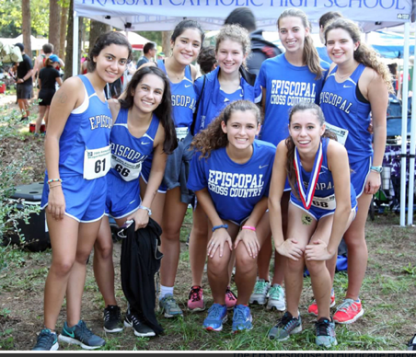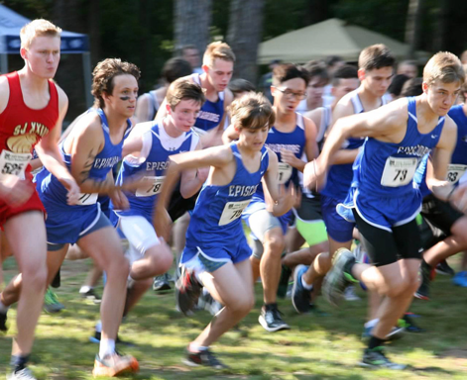
EPISCOPAL CROSS COUNTRY

Dear Knights,

We are very excited for the 2018 Cross Country Season!! The coaching staff cannot wait to meet all of the talented incoming freshmen runners. Below is a list of some upcoming dates for the 2018 season. We are going to have a team meeting on Thursday May 9th at 6:30pm. It is not mandatory, but we would love for you to come out if you can make it.
In the meeting we will discuss training plans for the summer and how prepare for the 2018 Cross Country Season. If you are unable to attend the meeting let me know and we can find a different date to meet/discuss training plans for the summer.

- Sports Physicals: May 9th @ 5:00pm Alkek Gym. Cost $20.
- Questions: Contact Coach Julius Michael @ jmichael@ehshouston.org or 713-512-3613.
- Summer Training Parent/Player Meeting: May 9th, 2018 6:30pm @ Anderson Lecture Hall
- Summer Group Runs: We would like to meet regularly 3-4 days a week after July 4th. This is not mandatory for incoming students, but we recommended it for those runners that are in Houston. We will send out more information at a later date.

GO KNIGHTS!!
Julius Michael

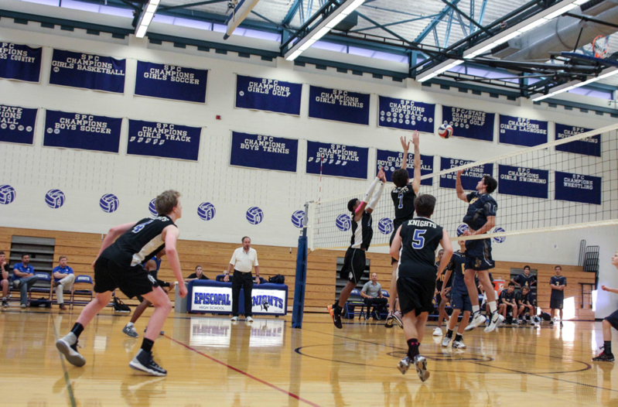
EPISCOPAL BOYS VOLLEYBALL

- Spring Volleyball: Open to new and current EHS students. No cost. Monday-Wednesday 4:00-5:30 @ Crum Gym
- Sports Physicals: May 9th @ 5:00pm Alkek Gym. Cost $20.
- EHS Volleyball Camps: June 11-14th and July 16th-19th.
Please go online to register @ EHS Volleyball Camp Registration
- Parent/Player Meeting: August 6th, 2018 5:00pm @ Crum Gym

If you have any questions, please contact Coach Mike Kent or Coach Kerry Hofmeister at mkent@ehshouston.org and khofmeister@ehshouston.org

GO KNIGHTS!

